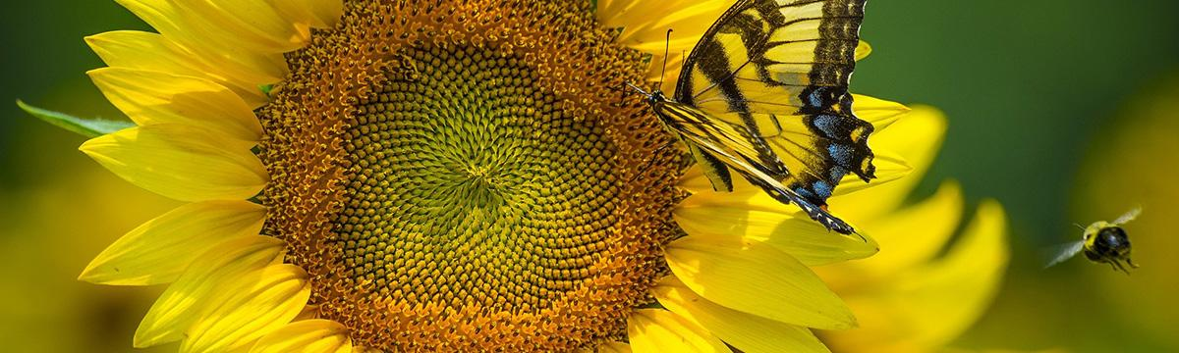

**POLLINATOR**

**PLEDGE**

Organization

Main Contact Name

Address

Email Address

Website

Phone

Number of Members

**~~~~~~~~~~~~~~~~~~~~~~~~~~~~~~~~~~~~~~~~~~~~~~~~~~~~~~~~~~~~~~~~~~~~~~~~~~~~~ ~**

**We commit to the following activities in support of the Pollinator Resolution**:

As a Pollinator Partner, you are encouraged to define what you or your organization choose to do in support of pollinators. There are countless options such as supporting regional partners in strategic pollinator planning, planting pollinator gardens, avoiding, or limiting pesticides, creating meadows and diversified lawns, implementing pollinator-friendly mowing practices, pollinator education outreach. You may have additional ideas. Please describe as best as possible to inspire others!

W

________________________________________________________________________________________________________________________________________________________________________________________________________________________________________________________________________________________________________________________________________________________________________________________________________________________________________________________________________________________________________________________________________________________________________________________________________________________________________________________________________________________________________________________________________________________________________________________________________________________________________________________________________________________________________________________________________________________________________________________________________________________________________________________________________________________________________________

________________________________________________________________________________________________________________________________________________________________________________________________________________________________________________________________________________________________________________________________________________________________________________________________________________________________________________________________________________________________________________________________________________________________________________________________________________________________________________________________________________________________________________________________________________________________________________________________________________________________________________________________________________________________________________________________________________________________________________________________________________________________________________________________________________________________________________

My signature represents my Rotary Club’s consideration of and commitment to Operation Pollination.

Name_________________________________________________________________________________Date_____________________________ 